THE TRIMURTI (Hindu Trinity): |  | SHAKTIS (female aspects):
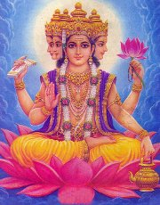  Click photo to enlarge | Brahma  The Creator  Vehicle: swan  Has 4 heads, 4 arms, and a reddish complexion  Not commonly worshipped  Not to be confused with Brahman (the ground of all being) or the Brahmin (priestly caste) | Saraswati  Goddess of knowledge, music, and the arts  Vehicle: swan  Wife of Brahma  Sits on a white lotus playing a veena | 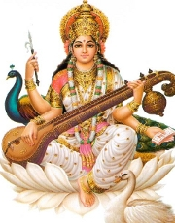  Click photo to enlarge
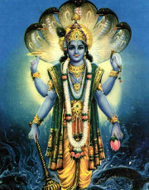  Click photo to enlarge | Vishnu  The Preserver  Vehicle: garuda (bird)  Has 4 arms, a blueish complexion, and rests on a snake  Was incarnated (born as an animal or human) nine times with one more still to come  Is the main god of Vaishnavism | Lakshmi  Goddess of wealth and prosperity  Vehicle: owl  Wife of Vishnu  Usually shown bestowing coins and flanked by elephants | 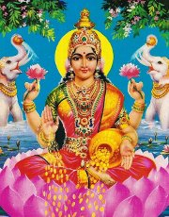  Click photo to enlarge
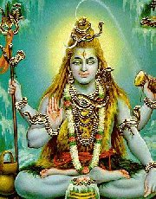  Click photo to enlarge | Shiva  The Destroyer / Transformer  Vehicle: bull  Has matted hair, a third eye, a blue throat and a trident in his hand  Often worshipped in the featureless lingam form  Is the main god of Saivism | Parvati  The Divine Mother  Vehicle: lion  The reincarnation of Shiva's first wife  Has many forms, such as the popular Durga and Kali (see below); often shown together with Saraswati and Lakshmi as the tridevi ('triple goddess') | 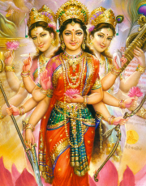  Click photo to enlarge

OTHER POPULAR HINDU GODS
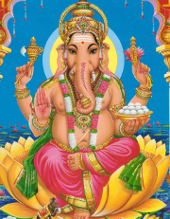  Click photo to enlarge | Ganesh  God of the intellect and the remover of obstacles  Vehicle: mouse  Son of Shiva & Parvati  Has an elephant's head | Murugan  God of war  Vehicle: peacock  Son of Shiva & Parvati  Popular in Tamil areas  Also known as Skanda | 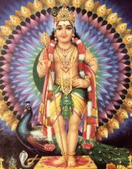  Click photo to enlarge
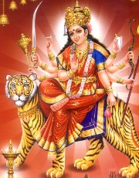  Click photo to enlarge | Durga  A fiercer form of Parvati  Vehicle: tiger  Has ten arms holding many weapons | Kali  Goddess of time and death  Vehicle: donkey  Usually portrayed as dark and violent | 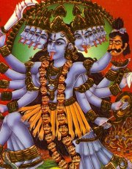  Click photo to enlarge
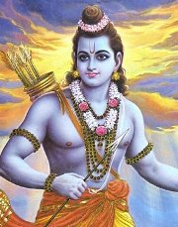  Click photo to enlarge | Rama  The 7th avatar (incarnation) of Vishnu  The central figure in the epic storyRamayana | Krishna  The 8th avatar (incarnation) of Vishnu  Asually portrayed as a child and a prankster; often shown playing the flute | 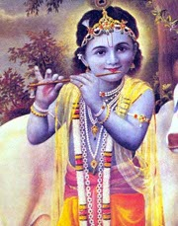  Click photo to enlarge
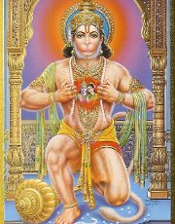  Click photo to enlarge | Hanuman  An ape-like god known for assisting Rama | Surya  God of the Sun  Pulled on a chariot by horses | 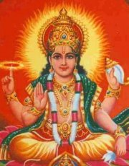  Click photo to enlarge

