Sui Dynasty

In 581 AD, a general named Wen Ti from northwest China succeeded in conquering the other two kingdoms and establishing a new dynasty in China, with emperors who ruled all of China like the Ch'in and the Han. This was the Sui Dynasty. Wen Ti made himself popular by trying to make the government better than it was during the Three Kingdoms. Wen Ti ordered that poor people in the countryside should pay less taxes than they had before. And he sent men around to all the provinces to count how many people there were and how much land and money each of them had (this is called a census) so that the government would know how much taxes that province should pay. He ordered that every man should get a certain amount of land to farm. When the man turned 60 and was too old to farm, he would stop paying taxes and give back some of the land, and pass on the rest to his sons.

Wen Ti also decided to go back to the Han Dynasty way of picking his government officials through the university and the great examinations, to find out who were the smartest and best educated men (Women were not allowed to be government officials at this time).
Wen Ti died while he was still not old. He may have been killed by his son, Yang Ti, who wanted to be the emperor himself. In any case Yang Ti did become the next Sui emperor. Yang Ti wanted to be a great emperor, so he began a lot of important projects. Yang Ti's best project was one where people dug a Grand Canal which connected the Yellow River with the Huai and Yangtze Rivers and made it much easier to get from northern to southern China and back again.
But Yang Ti's worst project was that he attacked Korea to try to take it over. He got together a great army of over a million men to invade Korea, but his great army was defeated and had to run away. The army generals were angry about this and killed Yang Ti. That was the end of the Sui Dynasty.

Tang Dynasty

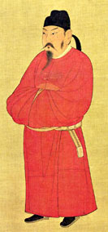
T'ai Tsung, 626 AD

Yang Ti, the last ruler of the Sui Dynasty, was killed in 618 ADby his generals, who blamed him for the disastrous defeat of the Chinese army in Korea. One of the generals, Li Shih-min, took over ruling the empire, putting his father, Li Yuan, on the throne as emperor. By 626, Li Shih-min made his father abdicate (retire) and took over being emperor himself, taking the new name T'ai Tsung. He made his capital at Chang'an. It became one of the biggest cities in the world at this time.

T'ai Tsung had a long reign and was a strong emperor. He continued the Han Dynasty way of choosing governors and judges on the basis of the great examinations, to see who was the smartest and the best educated. And he also continued theSui Dynasty way of giving each man a grant of land and collecting taxes equally from everyone. T'ai Tsung also took a census every three years to make sure that everyone paid the right amount of taxes. Under his rule, trade and cities began to become more important to China.

Later Tang Dynasty

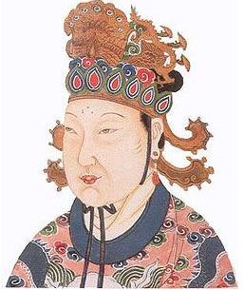
Empress Wu

Wu Chao was one of T'ai Tsung's girlfriends. After he died, she became his son's girlfriend too! His name was Gaozong. She used Gaozong's love for her to get rid of all his other girlfriends (some she had killed) and eventually he married her, so she became the empress. As empress, Wu Chao (woo-CHOW) was very active in politics. When Gaozong had a stroke in 660 AD and was too sick to rule, Wu Chao took over the government of China. In 684 AD, Gaozong died, and Wu Chao became the regent for her young son. In 690, when she was 64 years old, Wu Chao forced her son out altogether and made herself Empress of China, ruling on her own. Wu Chao was a devout Buddhist, but also promoted Taoism. She was a great ruler, and China was very successful both militarily and economically under her rule.
But in 705 AD, Wu Chao (now 79 years old!) was forced out of power. Nobody could agree about who would come after her, and so there was a long civil war.
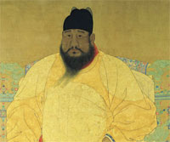
Emperor Hsuan Tsung

In 712 AD, Hsuan Tsung became the ninth T'ang emperor of China. Hsuan Tsung was a great emperor who ruled a long time, and he managed to greatly expand the borders of China, so that by 750 he ruled all the way to Tibet and the Sogdians in the west, and north to the Uighurs and Jurchen, and south to Vietnam, and even controlled Korea as theSui emperors had wanted. In 751, the Chinese army fought the Arabs in a great battle at Talas (Samarkand) in Uzbekistan. They lost the battle, but they succeeded in stopping the Arabs from invading China.

But in the last years of his life, Hsuan Tsung turned to art and philosophy, and lost interest in running his empire. Some people say that he was more interested in his girlfriend, Yang Kuei-fei. In the end, Hsuan Tsung's generals took over ruling in his place. One of these generals, a Sogdiannamed An Lu-shan, controlled the troops of north-west China. In 755 AD, An Lu-shan led a rebellion against Hsuan Tsung. Hsuan Tsung ran away to Szechwan with a small part of his army. Soon his army rebelled too. The army killed Yang Kuei-fei and made Hsuan Tsung abdicate (quit) and let his son be emperor.

Sung Dynasty
The first part of the Sung dynasty is called the Northern Sung. In 960 AD, one of the generals of the declining T'ang Dynasty managed to reunify China under his control. This general's name was Chao K'uang-yin, but once became emperor he renamed himself Sung T'ai Tsu. Sung T'ai Tsu was a strong emperor who kept the army firmly under his control, but after Sung T'ai Tsu died, his successors did not do as well, and China's defenses became weak. The Sung Dynasty never controlled as large an empire as the T'ang had. In 1004 AD, the Sung made peace with the Khitans in the north-east, and in 1044 they made peace with the Western Hsia in the north-west. The emperors had to pay heaps of gold to these people every year in order to keep them from attacking China.
On the other hand, the old Han Dynasty examinations became more and more important to Chinese government, and from the Sung dynasty on, these examinations were really the only way to get political power in China. But paying out the gold meant that poor people had to pay high taxes, and everyone was unhappy. Some people wanted to keep making the payments anyway, and other people thought it would be better to try to fight the northern invaders off. These two groups kept fighting with each other. First one would get into power and then the other.

Then about 1110 AD, the Sung emperor made an alliance with theJurchen of Manchuria to fight theKhitans and get them out of China. It worked great! But once the Khitans were out, in 1115, the Juchens took over the Sung capital of Kaifeng. The Jurchens took the emperor and his son prisoner.
The second part of the Sung dynasty is called the Southern Sung. Another son of the Sung emperor ran away to southern China and in 1126 he started a new Sung Dynasty with its capital at Hangzhou. He took the name Kao Tsung. Kao Tsung and his successors were not very strong militarily, and could not take back northern China from the Juchen. But they did develop thriving trade. Because the Juchen had cut off their traditional route along the Silk Road, traders began sailing to South-East Asia and to India. Paper money helped to create growth in the economy.
In the 1230s, the Sung Dynasty made an alliance with the Mongols to get rid of the Juchen. Again, the plan worked, but the Mongols took over northern China instead. In 1279 AD the Mongols came even further south and killed the last of the Sung emperors.

Yuan Dynasty – Mongols
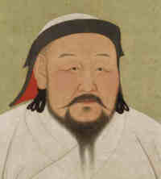
Kublai Khan
In 1276 AD, when theMongols invaded and took over China, they had already been ruling a large empire for about fifty years. Their empire stretched from India and Russia to northern China and Korea. In 1276 the Mongols captured theSung capital at Hangzhou, and by 1279 the Mongols controlled all of China. Kublai Khan, the Mongol leader, moved the capital of the Mongol empire from Karakorum in Central Asia to Beijing, China. In 1271, when he was 56, Kublai Khan declared himself emperor of China.

Kublai Khan tried to conquer Japan in 1274 and 1281 AD, but was prevented by a great storm. He also tried to recapture northern Vietnam (Annam) and Burma, but without much success. Even in China, Kublai Khan's rule was not very successful. The Chinese were very angry that Kublai Khan gave foreigners like the Venetian Marco Polo all the jobs as governors and judges, instead of choosing Chinese people. But Kublai Khan did not trust the Chinese. And the Chinese were also angry that the Mongols kept their own language and customs, and didn't want to act like the Chinese.

Kublai Khan died in 1294 AD. By the 1330s, people all over the whole Mongol Empire were suffering from the Black Death - the bubonic plague. Millions of people died in China. The plague made it hard to keep the empire together.

During the 1350s AD, a revolutionary movement called the Red Turbans became active in northern China. In 1356, the Red Turbans, under the leadership of Chu Yuan-chang, captured Nanjing. Chu Yuan-chang gradually conquered China, and threw out the Mongols. In 1368 AD Chu Yuan-chang declared himself emperor of China, under the name Hung-wu, and then he finally captured the Mongol capital at Beijing, starting the Ming Dynasty.

Ming Dynasty
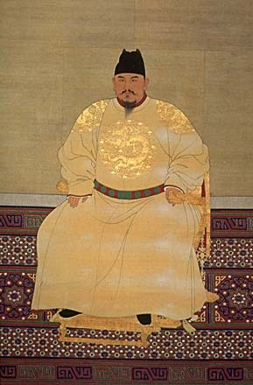
Hung-Wu (National Palace Museum, Taipei)
After Hung-Wu threw theMongols out in 1368 AD, he established the Ming Dynasty. But Hung-Wu's power was still pretty weak after the Mongol invasion. He only ruled China from the Great Wall to the east of Tibet - smaller borders than modern China or than T'ang Dynasty China. Hung-Wu modelled his government on the T'ang Dynasty, trying to keep as much power as possible in the central government and especially in his own hands. To deal with the extra work this made for him, he created a council of his advisers to help him. Examinations came back as a way to select governors and judges.

In 1451 AD, after a civil war, the emperor Yung-Lo moved the capital from Nanjing to Beijing (bay-ZING), where he began work on the imperial palace, which still stands today.

Later Ming Dynasty
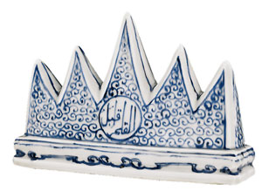
Brush rest showing five great mountains of Taoism,
but with Arabic writing (Ming Dynasty)

In 1505 AD, the Ming Dynasty emperor Zhengde succeeded hisfather as the emperorof China. Zhengde was only thirteen years old when his father died, and older men did most of the ruling. These men continued to build connections between China and the rest of the world. Many Muslim officials from the old Mongol Empire found new jobs with the Chinese government, and many people built mosques in China. China began to see more Europeans, too. In 1506, Portuguese explorers reached southern China by boat and did some trading there. In 1513, King Manuel I of Portugal sent official messages to Zhengde.
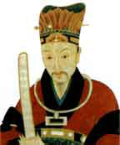
Yan Song (ca. 1550 AD)

Zhengde died in 1521 AD, when he was thirty years old. Zhengde's cousin, Jiajing, became the new Emperor, but he didn't have any power either, and his advisor Yan Song ruled in his name. Later Yan Song was able to pass power to his own son, Yan Shifan. Yan Song and Yan Shifan had to fight off Mongol invasions from the north. They tried to keep Chinese traders from trading with Japan, but people just broke the law and traded anyway; this led to trouble with pirates in the Pacific Ocean. Because Ming Dynasty rulers thought that all traders on the Pacific Ocean were pretty much pirates, they also banned Portuguese traders. Like the Japanese traders, the Portuguese traders continued to trade illegally, as pirates.

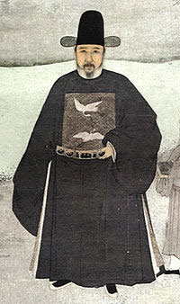
Zhang Juzheng (Ming Dynasty, died 1521 AD)

When Jiajing died in 1567, his son Longqing became the emperor. Longqing tried to get power back into his own hands, firing many of his father's ministers and choosing new ones, but soon he realized that he couldn't really get power. During Longqing's reign, the government was run by Zhang Juzheng. Longqing died after only six years in power, and the next emperor was Longqing's son Wanli, who was only nine years old. Of course Zhang Juzheng kept on running the government. Zhang Juzheng did a good job. But when Zhang Juzheng died, in 1582, Wanli was 19 years old, and, like his father, he tried to get power back for himself. For a few years, Wanli succeeded. He fought off the Mongols. But by 1600, he too had lost power to his advisors. In the early 1600s, Wanli's army got smaller and weaker, while the Jurchens got stronger and stronger.

In 1620, Wanli died and his son Taichang took over. Taichang tried right away to make himself popular by giving lots of silver to the soldiers and cutting taxes on the people, even though really China wasn't rich at this time and couldn't afford to have less money. But Taichang died of dysenterya month later, so Taichang's son Tianqi became the emperor. Tianqi was only fifteen years old, so of course he wasn't the one to get back power for the Ming Emperors, and he didn't. Tianqi's chief adviser, Wei Zhonxian, and the woman who had been his wetnurse, Ke, took control. The Ming Dynasty continued to lose power, and people began to revolt against the government. When Tianqi died in 1627, he was still only 22 years old. His younger brother, Chongzhen, became the emperor at 17, and immediately killed Wei and Ke, trying to get power for himself. But the Manchus kept invading and the Chinese people kept revolting. The weak Ming army could not fight both threats at the same time. Finally in 1644, one of the rebel commanders captured Beijing. The emperor Chongzhen killed himself and his family. But less than a year later Beijing fell to the Manchu army. Their leader set himself up as Shunzhi, the first emperor of the Qing Dynasty.

